**Full Title**: Automatic Identification of Cirrhosis on Brain MRI Based on Manganese Related Increase in T1 Signal Intensity

**Authors**: Ke Wei1, Patrick Chan2, Thao Tran1, Karen Chu1, Matthew Borzage3, Ed Mena4, Kevin King1

1 Advanced Imaging and Spectroscopy Center, Huntington Medical Research Institutes, Pasadena, CA, USA

2 Patrick’s affiliation

3 Fetal and Neonatal Institute, Division of Neonatology Children's Hospital Los Angeles, Department of Pediatrics, Keck School of Medicine, University of Southern California, Los Angeles, CA, USA

4 Dr. Mena’s affiliation

**Footnotes:**

1. **Conflicts of interest:** The authors have no conflicts of interest to disclose.
2. **Corresponding author:** Kevin King; 10 Pico Street, Pasadena, California, USA, 91105; Email: [Kevin.King@HMRI.org](mailto:Kevin.King@HMRI.org); Phone: (626)389-3427

**Abstract**

Introduction: The purpose of this study was to evaluate automated T1 signal intensity assessment to identify differences among patients with cirrhosis compared with controls in the cerebral white matter, brainstem, putamen and globus pallidus.

Method: We acquired T1 FSPGR on 29 cirrhotic patients (22F:7M; age: 63±2) and 30 age-matched controls (15F:15M; age: 62±2). FreeSurfer T1 signal intensity (SI) values were obtained for the globus pallidus, putamen, cerebral white matter, and brainstem. Between group differences in SI and SI ratios (basal ganglia regions normalized to white matter and brainstem) were calculated using t-tests with significance at p<.05 after false discovery rate adjustment.

Results: T1 SI ratios for cirrhosis versus controls was 7% greater for globus pallidus to cerebral white matter (p<0.001), 6% greater for globus pallidus to brainstem (p=0.002), 4% greater for putamen to cerebral white matter (p=0.002) and 4% greater for putamen to brainstem (p=0.002). T1 SI for cirrhosis compared with control was 63% greater for globus pallidus (p<0.001), 58% greater for putamen (p<0.001), 53% greater for cerebral white matter (p<0.001), and 52% greater for brainstem (p<0.001).

Conclusion: Automated assessment showed increased T1 SI in the cerebral white matter and the brainstem as well as in the globus pallidus and putamen which is consistent with global deposition of neurotoxic manganese. FreeSurfer T1 SI showed at least equivalent ability to identify between group differences as SI ratios. Automated assessments can provide objective measures in multiple anatomic regions to identify extent and distribution of manganese deposition in cirrhosis and potentially for other conditions impacting T1 SI.

**Introduction**

There is considerable interest in the development of automated tools to aid disease screening and diagnostic efforts to increase the speed of image interpretation while providing reproducible disease markers8,9. Automated image analysis using programs such as FreeSurfer are now routinely employed for assessment of brain volumes to identify impact of disease. The process of tissue segmentation also usually involves normalizing signal intensities within the MRI image and generation of standardized intensity values that are used for tissue classification. T1 signal intensity values are automatically calculated by FreeSurfer for each of the regions that it segments, but this value is not widely used in research. In this study, we aimed to utilize the FreeSurfer automated assessment of T1 signal intensity for different anatomic brain regions to identify effects of T1 shortening from manganese deposition in patients with Cirrhosis.

In cirrhotic patients, increased manganese (Mn) deposition in the brain is related to increased concentration in the bloodstream due to portal shunting and failure of hepatobiliary clearance of metabolites from the intestines.1 Mn accumulation may contribute to a multifactorial process along with other neurotoxins to cause neurotransmitter dysregulation and neuron and astrocyte dysfunction that contribute to hepatic encephalopathy.2,3 Studies evaluating T1 signal intensity (SI) in the basal ganglia of cirrhotic patients have relied on manually drawn regions of interest (ROI) and the use of ratios where signal intensity of targeted region is compared to that of background tissue.1,4-6 Using the white matter and brainstem as reference regions is problematic, however, as pathology studies demonstrate diffuse Mn deposition in these throughout the brain, including in these background regions7. Additionally, manually drawn ROIs are subjective and may introduce operator errors.

We hypothesized that direct comparison of T1 SI using the automated brain segmentation program would identify T1 SI differences in the cerebral white matter and brainstem in addition to the putamen and globus pallidus in patients with cirrhosis compared to controls.

**Method**:

In this IRB-approved study with written consent, 29 cirrhotic (22F:7M; age 63±2) patients and 30 age-matched controls were completed brain MRI exams on a General Electric 3 Tesla scanner. Cirrhosis was diagnosed by laboratory evidence of liver disease (from commercial clinical laboratory) along with: FibroScan > 14kilopascals10, serum albumin <3.5 g/l, platelets <150,000/mm3 11, nodular liver surface12 or hospital admission for bleeding varices, ascites or hepatic encephalopathy. Our cirrhosis cohort consisted entirely of patients with non-alcoholic steatohepatitis which was diagnosed by presence of fatty infiltration not explained by presence of alcoholism, medications or hereditary disorders13.

3D T1 fast spoiled gradient echo was obtained with echo time 2.41ms, repetition time 6.75ms, inversion time 600ms, slice thickness 1.2mm; matrix 256 x 256; flip angle 8 degrees. Averaged T1 SI of the combined left and right cerebral white matter, globus pallidus, and putamen and brainstem SI were obtained from the brain extracted image (brain.mgz) generated by FreeSurfer image analysis suite 6.014. FreeSurfer performs a nonparametric nonuniform intensity normalization which is meant to be compatible with different MRI sequences and for the presence of pathology, as previously described 15. Our T1 technique follows the guidelines of Neuroquant which enables us to provide clinical volumetric assessments16. For GE, this protocol requires that surface coil intensity correction is turned off as the Neuroquant also uses its own proprietary intensity normalization. SI ratios for globus pallidus and putamen, each normalized to cerebral white matter and to brainstem, were also calculated.

SI and SI ratios were compared between cirrhosis and control using t-tests with significance at p<.05 after false discovery rate adjustment. Age and sex were not significantly associated with SI or SI ratios and were not included in the analyses. All statistical analysis was performed using JMP Pro version13 (SAS, Cary NC).

**Results**:

Study demographic information is shown in Table 1. Figure 1 shows sample FreeSurfer processed brain axial views for a control and a cirrhotic patient.

SI Ratio: Figure 2 reports T1 SI ratio differences between control and cirrhosis for the globus pallidus: cerebral white matter, globus pallidus: brain stem, putamen: cerebral white matter, and putamen: brainstem. All SI ratios were greater in cirrhosis compared to control with globus pallidus to cerebral white matter showing the greatest between-group difference of 7% (Figure 2A), followed by globus pallidus to brainstem at 6% (Figure 2B), and lastly putamen to cerebral white matter (Figure 2C) and putamen to brainstem (Figure 2D) both at 4% difference.

SI: The SI of all four regions was significantly greater in cirrhosis compared with control as shown in Figure 3. Among these four regions, globus pallidus (Figure 3B) showed the greatest between-group difference of 62%, followed by 53% in the cerebral white matter (Figure 3C) 58% in the putamen (Figure 3A) and 52% in the brainstem (Figure 3D).

**Discussion**:

We found that an automated approach is able to identify increased T1 SI in multiple brain regions in patients with cirrhosis compared with controls. Importantly, we were able to demonstrate differences in SI for the cerebral white matter and brainstem in addition to the globus pallidus and putamen. T1 SI increase between cirrhosis and controls for all the evaluated brain regions is consistent with widespread manganese deposition. Normally, SI differences in the white matter and brainstem are not evaluated as clinical markers since these areas are included adjustment or normalization factors to generate SI ratios focusing on the basal ganglia. Automated SI ratios also demonstrated group differences between cirrhosis and control groups (Figure 3) with similar statistical significance as those seen with SI values for evaluated brain regions.

Automated identification of T1 SI differences may have important implications in following the impact of manganese neurotoxicity in areas outside the basal ganglia. This may help to explain the complex spectrum of deficits seen with hepatic encephalopathy, such as deficits in memory and attention that are not readily explained by basal ganglia insults 17. Regional assessment of manganese deposition with T1 SI may assist with current efforts to go beyond assessment of HE as a binary condition and instead use imaging to identify a continuum of distinct brain impacts seen with HE 18. We could not find prior reports of increase T1 SI in the white matter and brainstem in cirrhosis but our finding is concordant with multiple radiological-pathological studies noting diffuse manganese deposition 1,4-6 and T1 shortening identified by quantitative assessment of T1 relaxation rate outside the basal ganglia in patients with chronic liver disease6. Diffuse, symmetric differences in SI are difficult to visually identify as shown in the brain images in Figure 1. In order to objectively compare T1 SI between different studies, it is necessary to account for fluctuations in SI among sequences and MRI scanners. Assessment with SI ratios that use background regions for adjustment provides a more objective assessment and helps account for SI fluctuations but ideally requires regions not impacted by the disease process to serve as reference regions. The concordant SI changes in the white matter and brainstem as seen in the basal ganglia regions in cirrhosis will tend to decrease power to identify differences.

Our findings point to the utility of image-based normalization techniques for SI. Identification of manganese T1 SI differences for regions of interest without use of ratios was facilitated by use of T1 signal intensity values generated as part of the FreeSurfer14,19 image analysis pipeline. FreeSurfer uses nonparametric approaches to normalize images’ intensity to remove impact of technical differences and fluctuations in signal intensity that may interfere with intensity-based segmentation15. Our identification of SI differences in the white matter and brainstem may also have been facilitated by use of T1 sequences with more sensitivity for manganese effects. We used a Fast Spoiled Gradient Echo which is now a standard for acquiring high-resolution images for automatic segmentation. This sequence has different signal characteristics compared to standard spin echo sequences typically obtained in the clinic and may be more sensitive to the effects of T1 shortening related to manganese, similar to what has been reported for detection of gadolinium20.

There are some limitations to our study. Normalization of SI was aided by using the same MRI scanner and the same sequence parameters for all participants in this study. Image analysis experts also continue to refine algorithms for intensity normalization which may help address these issues21. Validation will be needed in clinical based settings which may require the use of phantoms. New imaging sequences such as synthetic MRI22 which quantify T1 and T2 may excel at objective assessment of manganese deposition. Automated assessments of T1 SI may also reflect influence of gadolinium deposition from prior MRI scans 23. Automated assessment for gadolinium deposition also has significant clinical utility but this complicates identification of manganese. This was not an issue in our current study as we follow American Association for the Study of Liver Diseases guidelines that favor ultrasound and CT rather than gadolinium-contrast for hepatocellular carcinoma surveillance in patients with cirrhosis13. Confounding due to effects of gadolinium may be less of an issue in the future as linear contrast agents implicated in tissue deposition 24 are replaced with macrocyclic agents.

**Conclusion**:

Automatic assessment of T1 SI allows for rapid objective identification of manganese deposition in cirrhosis. T1 SI increase was shown for the cerebral white matter and brainstem, in addition to the globus pallidus and putamen, consistent with global deposition of neurotoxic manganese seen in pathology studies. In addition to helping identify manganese deposition in cirrhosis, automated T1 assessment may have broader utility for other conditions impacting T1 SI.

Table 1: Study population demographics and clinical laboratory parameters.

|  |  |  |
| --- | --- | --- |
| Study | Control | Cirrhosis |
| (N=30) | (N=29) |
| Age | 62.9±2.4 | 63.1±2.4 |
| Female: Male | 15:15 | 22:7 |
|  |  |  |
| Diabetes Mellitus Type II | 0 | 23 |
|  |  |  |
| Laboratory and clinical parameters |  |  |
| MELD score  Albumin | N/A  N/A | 9.87±4.06  3.8±0.1 |
| INRa | N/A | 1.16±0.03 |
| Alanine transaminase (ALT) | N/A | 33.2±3.1 |
| Aspartate transaminase (AST) | N/A | 40.4±3.9 |
| Creatinine | N/A | 0.87±0.08 |
| Sodium | N/A | 139.5±0.65 |

a INR: international normalized ratio

Figure 1: Sample 3D T1 FSGPR axial view of control and cirrhosis subjects after FreeSurfer image intensity normalization.

Figure 2: Normalized T1 SI of globus pallidus and putamen with respect to cerebral white matter and brainstem after adjusted for false discover rate.

Figure 3: Signal intensity without normalization from four regions of interest: putamen (A), globus pallidus (B), cerebral white matter (C), and brainstem (D). p-values adjusted for false discover rate.

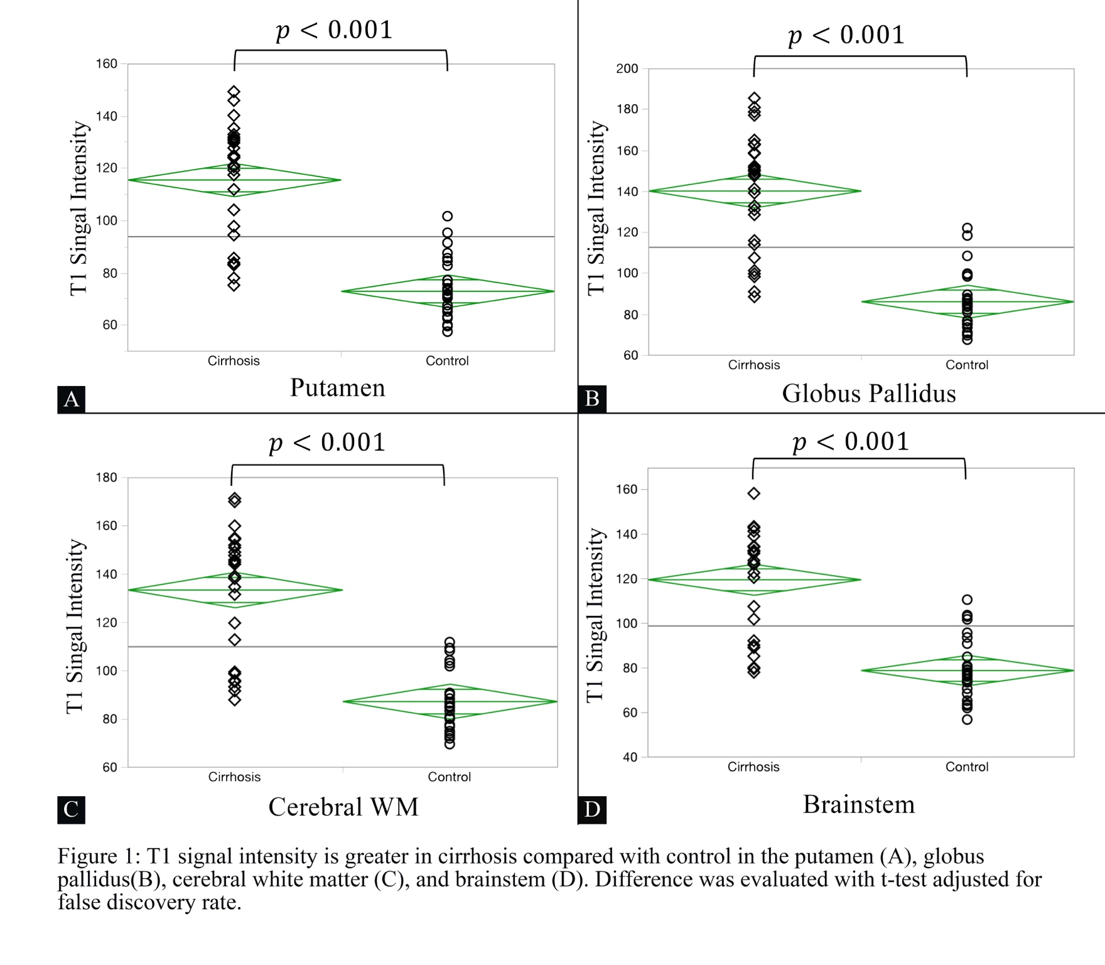

References:

1. Pinto RB, Froehlich PE, Pitrez EH, et al. MR findings of the brain in children and adolescents with portal hypertension and the relationship with blood manganese levels. *Neuropediatrics.* 2010;41(1):12-17.

2. Lockwood AH, Yap EW, Wong WH. Cerebral ammonia metabolism in patients with severe liver disease and minimal hepatic encephalopathy. *Journal of cerebral blood flow and metabolism : official journal of the International Society of Cerebral Blood Flow and Metabolism.* 1991;11(2):337-341.

3. Aldridge DR, Tranah EJ, Shawcross DL. Pathogenesis of hepatic encephalopathy: role of ammonia and systemic inflammation. *Journal of clinical and experimental hepatology.* 2015;5(Suppl 1):S7-s20.

4. Krieger D, Krieger S, Jansen O, Gass P, Theilmann L, Lichtnecker H. Manganese and chronic hepatic encephalopathy. *Lancet.* 1995;346(8970):270-274.

5. Rose C, Butterworth RF, Zayed J, et al. Manganese deposition in basal ganglia structures results from both portal-systemic shunting and liver dysfunction. *Gastroenterology.* 1999;117(3):640-644.

6. Vymazal J, Babis M, Brooks RA, et al. T1 and T2 alterations in the brains of patients with hepatic cirrhosis. *AJNR Am J Neuroradiol.* 1996;17(2):333-336.

7. Maeda H, Sato M, Yoshikawa A, et al. Brain MR imaging in patients with hepatic cirrhosis: relationship between high intensity signal in basal ganglia on T1-weighted images and elemental concentrations in brain. *Neuroradiology.* 1997;39(8):546-550.

8. Choy G, Khalilzadeh O, Michalski M, et al. Current Applications and Future Impact of Machine Learning in Radiology. *Radiology.* 2018;288(2):318-328.

9. Ashburner J, Neelin P, Collins DL, Evans A, Friston K. Incorporating prior knowledge into image registration. *Neuroimage.* 1997;6(4):344-352.

10. Degos F, Perez P, Roche B, et al. Diagnostic accuracy of FibroScan and comparison to liver fibrosis biomarkers in chronic viral hepatitis: a multicenter prospective study (the FIBROSTIC study). *Journal of hepatology.* 2010;53(6):1013-1021.

11. Qamar AA, Grace ND, Groszmann RJ, et al. Incidence, prevalence, and clinical significance of abnormal hematologic indices in compensated cirrhosis. *Clinical gastroenterology and hepatology : the official clinical practice journal of the American Gastroenterological Association.* 2009;7(6):689-695.

12. Simonovsky V. The diagnosis of cirrhosis by high resolution ultrasound of the liver surface. *The British journal of radiology.* 1999;72(853):29-34.

13. Chalasani N, Younossi Z, Lavine JE, et al. The diagnosis and management of nonalcoholic fatty liver disease: Practice guidance from the American Association for the Study of Liver Diseases. *Hepatology (Baltimore, Md).* 2018;67(1):328-357.

14. Dale AM, Fischl B, Sereno MI. Cortical surface-based analysis. I. Segmentation and surface reconstruction. *Neuroimage.* 1999;9(2):179-194.

15. Sled JG, Zijdenbos AP, Evans AC. A nonparametric method for automatic correction of intensity nonuniformity in MRI data. *IEEE Trans Med Imaging.* 1998;17(1):87-97.

16. Labs C. Neuroquant 3.0 Scanner Parameters. https://files.cortechslabs.com/index.php/s/GOnOYaYaMcUfbdq#pdfviewer. Accessed 12-1-2012, 2012.

17. Khungar V, Poordad F. Hepatic encephalopathy. *Clinics in liver disease.* 2012;16(2):301-320.

18. Kim HK, Lee HJ, Lee W, Kim YS, Jang HW, Byun KH. Pattern approach to MR imaging in patients with end-stage hepatic failure: a proposal for a new disease entity “hepatic encephalopathy continuum”. *Neuroradiology.* 2008;50(8):683.

19. Reuter M, Schmansky NJ, Rosas HD, Fischl B. Within-subject template estimation for unbiased longitudinal image analysis. *Neuroimage.* 2012;61(4):1402-1418.

20. Crombé A, Saranathan M, Ruet A, et al. MS Lesions Are Better Detected with 3D T1 Gradient-Echo Than with 2D T1 Spin-Echo Gadolinium-Enhanced Imaging at 3T. *American Journal of Neuroradiology.* 2015;36(3):501-507.

21. Tustison NJ, Avants BB, Cook PA, et al. N4ITK: improved N3 bias correction. *IEEE Trans Med Imaging.* 2010;29(6):1310-1320.

22. Tanenbaum LN, Tsiouris AJ, Johnson AN, et al. Synthetic MRI for Clinical Neuroimaging: Results of the Magnetic Resonance Image Compilation (MAGiC) Prospective, Multicenter, Multireader Trial. *AJNR Am J Neuroradiol.* 2017;38(6):1103-1110.

23. Kang KM, Choi SH, Hwang M, Yun TJ, Kim JH, Sohn CH. T1 Shortening in the Globus Pallidus after Multiple Administrations of Gadobutrol: Assessment with a Multidynamic Multiecho Sequence. *Radiology.* 2018;287(1):258-266.

24. Choi JW, Moon W-J. Gadolinium Deposition in the Brain: Current Updates. *Korean J Radiol.* 2019;20(1):134-147.